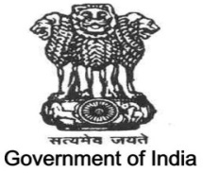

INTEGRATED DISEASE SURVEILLANCE PROGRAMME (IDSP)
(2020-21)
- BACKGROUND

At national level Integrated Disease Surveillance Programme (IDSP) was launched by Hon’ble Union Minister of Health & Family Welfare in November 2004. It is a decentralized, State based Surveillance Program in the country. It is intended to detect early warning signals of impending outbreaks and help initiate an effective response in a timely manner.
Major components of the programme are:
(1) Integrating and decentralization of surveillance activities;
(2) Strengthening of public health laboratories;
(3) Human Resource Development – Training of health care workers involved
(4) Use of Information Technology.

In Sikkim, Integrated Disease Surveillance Project was launched in Ph III (2006-07) on 1st April 2006.

Currently surveillance is working on three aspects of diseases surveillance.
- SYNDROMIC
- PRESUMPTIVE
- CONFIRMED

- ▪ SYNDROMIC - Diagnosis made on the basis of clinical pattern by paramedical personnel and members of community. This include fever, fever with rashes, fever with bleeding, diarrhea without dehydration, diarrhea with dehydration, diarrhea with blood, cough less than 3 weeks and more than 3 weeks, fever with daze or semi/unconsciousness.

- ▪ PRESUMPTIVE - Diagnosis is made on typical history and clinical examination by medical officers. This includes Acute Diarrheal diseases, Acute Respiratory Diseases, Measles, Chicken Pox, Dengue, Bacillary Diarrhea, Viral Hepatitis, Enteric fever, Malaria, Chikungunya, Acute Encephalitis syndrome, meningitis, diphtheria, Pertusis, Pneumonia, Fever of unknown disease, acute flaccid paralysis, Leptospirosis, dog-bite, snake bite.

- ▪ CONFIRMED - Clinical diagnosis by medical officer and/or positive laboratory identification. This includes typhoid fever, dengue, hepatitis, malaria, tuberculosis, cholera, shigella dysentery, diphtheria, chikungunya, meningococcal meningitis, leptospirosis and others.

In 2013 Vaccine Preventable Disease (VPD) Surveillance and Unnatural deaths and suicidal surveillance was initiated.

- CURRENT STATUS- FINANCIAL AND PHYSICAL

PHYSICAL STATUS OF IDSP
- MANPOWER OF IDSP, SIKKIM
Designation | SSU | DSU | Medical College(CRH) | Total | Nature of Post | Status
SSO | 2 | 0 | 0 | 2 | Regular | Active
DSO | 0 | 4 | 0 | 4 | Regular | Active
Training Consultant | 1 | 0 | 0 | 1 | Regular | Inactive
Epidemiologist | 1 | 0 | 0 | 1 | Contractual | Active
Entomologist | 1 | 0 | 0 | 1 | Regular | Active
Financial Consultant | 1 | 0 | 0 | 1 | Contractual | Active
Microbiologist | 0 | 2 | 0 | 2 | Regular(1)  Contractual(1) | Active
State Data Manger | 1 | 0 | 0 | 1 | Regular | Active
District Data Manger | 0 | 4 | 0 | 4 | Regular(2)  Contractual(2) | Active
DEO | 1 | 4 | 1 | 6 | Regular | Active
Lab Technician | 1 | 0 | 0 | 1 | Contractual | Active

- CAPACITY BUILDING (WORKSHOPS AND TRAINING)
Sl NO | Trainees | Year of Training | Total Trained
1 | DSO/MEDICAL SPCEIALIST/MO/DATA MANGER/DEO/Lab Technician | 2020-21 | 114

- COMMITTEE AND SURVEILLANCE
State Surveillance Unit and District Surveillance Unit were established in year 2006. In all four Districts and State RRT (Rapid Response Team) for outbreak investigation and control are in function. These RRTs were framed in year 2007-08. State and district Influenza epidemic preparedness and response committees formed in Jan 2009.State and District Surveillance Committees formed in 2020.

- PROGRAMME PLAN OF FINANCIAL YEAR (2020-21)
PHYSICAL ACHIEVEMENTS.
- Advisory on nCoV, daily reporting formats, travel advisory, clinical management guidelines, testing strategies were sent to districts, hospitals and also apprised to higher authorities since 1st January 2020.
- Video Conferencing in regard to 2019 nCoV current situation, preparedness and public health interventions being undertaken was conducted on 27th January 2020 under the chairmanship of Chief Secretary (Sikkim) with Union Secretary Health.
- Reporting from 5 check posts four interstate (Sikkim-North Bengal) and one international border (Indo- Nepal) from 29th Jan 2020.
- The surveillance and monitoring of COVID-19 initiated from 27th January 2020 till 12th March 2020 which was done by State Surveillance Unit, District Surveillance Unit and STNM Hospital and District Hospital. The logistics during this phase were provided by a pharmaceutical company and CMS.
- Media Briefing on 2019 nCoV at Prasar Bharati Doordarshan , by DG cum Secy and SSO (IDSP) on 03rd Feb 2020.
- Review on preparedness for prevention of Novel Corona virus infection (nCoV) in the state of Sikkim with State RRT members at conference hall Health Secretariat on 3rd Feb 2020.
- VC conveyed with Health & Family Welfare Secretary MoHFW at NIC, Gangtok on 4th Feb. 2020
- 2019 nCoV sensitization meeting for PHCs staffs under Gyalshing by DSO/West at DHG conference Hall on 4th Feb 2020.
- Video Conferencing for demonstration of IT application for nCoV conducted at SSU on 5th Feb 2020.
- A meeting on COVID-19 preparedness of Infection Control Committee and RRT (DH Singtam) was organized on 5th Feb 2020 under the chairman ship of Chief Medical Officer (East).
- Demonstration of PPE to Infectious disease management staff at Isolation Ward New STNM hospital on 6th Feb 2020.
- Orientation for West District hospital RRT conducted to Medical Officers, ANM, staffs, Counselor and other staffs under the chairmanship of CMO (W) , on 7th Feb 2020.
- Video Conferencing with GoI conducted with Secretary Ministry of Health attended by Principal Secretary (H), DG cum Secy (H) and SSO at NIC Gangtok on 10th Feb 2020.
- Press Conference with media personnel in regard to State Preparedness for 2019 nCoV held at Health Secretariat Conference hall on 5th Feb 2020.
- Clarification to general public through Press Release done on 07th Feb 2020 for misguiding rumor, videos, and audios circulated in the social media
- Desktop Video Conferencing attended by Entomologist and State Data Manager in regard to review the progress and issues related to nCoV on 10th Feb 2020
- During PHASE I of COVID-19 outbreak State Surveillance Unit, IDSP of Health & Family Welfare Department was assigned as the nodal unit for surveillance and monitoring of COVID-19.
- Meeting on COVID-19 was called for the villagers of Utteray, Panchayats from Kumbuk Sepi, Sopakha, Gumpadara and students of Utteray Sr. Sec School which was chaired by central team along with DSO, west on 19th Feb 2020.
- Meeting conducted by central team in regard to Gram Sabha, checkpost screening for COVID-19was held in the chamber of SDM, West Sikkim on 20th Feb 2020.
- Video Conferencing attended by districts and headquarters in regard to WHO National Training of Trainers for COVID-19 online tutorial the state team JD IDSP, HoD Medicine, HoD Microbiology and State IEC Officer attended the training on 6th March 2020.
- After COVID-19 was declared as PANDEMIC on 11th March 2020, the intradepartmental meeting was held on 13th March 2020 under the chairmanship of DG cum Secretary (Health) at European Commission Hall wherein various officials of the state health department were assigned for different duties and responsibilities of COVID-19.
- State ToT training on COVID-19 conducted at European Hospital, Gangtok to Medical officers HoD’s of STNM Hospital, District hospital team, Military personnels, NHPC doctors on 12th March 2020 by ToT and WHO co-coordinator who were trained on Delhi for National ToT.
- 2 batches District level ToT on COVID-19 treatment, supervision conducted to the Medical Officers, Consultants and Health Officers of Namchi District Hospital on 16th March 2020.
- Training on COVID-19 management to all staff including PHC, PHSC of North district on 18th March 2020.
- Video conference with Honb’le Prime Minister attended by DGHS and SSO IDSP, Govt. of Sikkim on 20th March 2020.
- Mock drill in regard to COVID-19 performed at STNM Hospital on 22nd March 2020
- Testing of COVID-19 Samples for RT-PCR was being sent to NBMC, Siliguri from 26th March 2020 to 28th May 2020.
- Training on Role of Frontline Warriors conducted via ZOOM app on 28th March 2020.
- Control room for COVID-19 was established on 28th March 2020 at ground floor of Health Secretariat, Tashiling which was previously conference hall of the department.
- Health Bulletin started on facebook page Health of Sikkim in collaboration with Stars of Hope NGO from 30th March 2020.
- VC with MDs of all the states & UTs of India on hotspots update on COVID-19 through Zoom on 16th April 2020.
- VC with Secretary MOHFW, secretary ICMR along with all state MDs, SSOs, and other data Managers regarding updating of COVID-19 data in the portal 30th April 2020
- The facilities were upgraded and enhanced by increasing the no of wards, beds and establishment of new virology lab (VRDL) at STNM Hospital.
- Establishment & construction of VRDL lab at STNM Hospital, Sichey.
- TRUENAT test initiated from 4th May 2020
- VRDL established on 21st May 2020 wherein RT- PCT testing of suspected patient initiated from 29th May 2020
- Identification of more quarantine centers at state and districts.
- Press release in regard to 1st COVID-19 case done on 23rd May 2020.
- Press Conference and SoS meeting conducted at Health Secretariat in regard to first case reported in Sikkim on 23rd May 2020.
- Director-cum SPO (NVBDCP/IDSP) attended VRDL inauguration program at New STNMH inaugurated by Hon’ble Chief Minister of Sikkim on 21st May 2020.
- On 30th May 2020 started Covid-19 testing at Virology Lab STNMH.
- First meeting of Technical committee of Covid-19 with new chairman.
- Director-cum SPO (NVBDCP/IDSP), JD(IDSP) attended VC on PMGKP on 5th June 2020.
- Press Conference at DG cum Secretary’s chamber in regard to new 6 positive cases on 09th June 2020.
- MD (NHM), Director-cum SPO (NVBDCP/IDSP) and State Data Manager attended VC on S3 portal at NIC on 20th June 2020
- Director-cum SPO (NVBDCP/IDSP), JD(IDSP) attended Technical Committee meeting held at Health Secretariat chaired by Principal Secretary Health on 10th July 2020
- One State Epidemiologist appointed under IDSP in August 2020.
- One District Data Manager appointed under IDSP for North District on 10th June 2020.
- State Epidemiologist and State Data Manger attended VC for Covid-19 portal on 11th August 2020
- On 16th January 2021 attended launching program of Covid vaccination for health workers.
- Virtual training conducted on IHIP by CSU attended by Director-cum SPO (NVBDCP/IDSP), JD(IDSP), Epidemiologist and State Data Manager on 22th Feb 2021.
- On 9th & 10th March 2021 ToT on IHIP for Medical Specialists, Pediatrician, Microbiologists, DSOs/MOs PHC/STNMH/CRH conducted by SSU.
- Director-cum SPO (NVBDCP/IDSP), JD (IDSP) and Epidemiologist attended State Task force meeting on Malaria elimination chaired by Principal Secretary Health on 19th March 2021.
- Director-cum SPO (NVBDCP/IDSP), JD (IDSP) and Epidemiologist attended VC on implementation of IHIP conducted by NCDC chaired by Director NCDC on 26th March 2021.
- VC meeting with CMOs/DSOs conducted by SSU on preparedness of second wave of Covid-19 on 30th March 2021.
- National lunching of IHIP virtually attended by Hon’ble Ministry, Principle Secretary, DGHS, PDHS-cum- MD, DHS-cum-SSO and SSU Staffs on 5th April 2021.
- VC on PMGKP claim to be filled in new format, attended by DHS-cum –SSO-IDSP, JD IDSP and Epidemiologist on 2nd June 2021.
- Technical committee meeting for preparedness of 3rd wave of Cocid-19 on 14th June 2021.
- Two PMGKP beneficiaries received the amount of Rs 50 lakhs each on 16th June 2021.
- VC meeting on WGS and INSACOG with Director NCDC attended by JD IDSP and Epidemiologist in 18th August 2021.
- Technical Committee meeting at conference hall to discuss on Delta Variant and high court queries on Covid-19 and Rat testing on 20th July 2021.
- One PMGKP beneficiary received the amount of Rs 50 lakhs on 12th July 2021.
- Video Conference meeting with Director NCDC and CSU teams attended by JD IDSP on 20th August 2021.
- VC on ECRP, WGS and Vaccination with Secretary MoHFW GoI attended by JD IDSP on 25th August 2021.
- VC meeting with Union Health Secretary on Oxygen and Ventilators status attended by PDHS-cum –MD NHM and JD IDSP on 27th August 2021.
- Visited by State Nodal Officer for Sikkim from CSU NCDC Delhi for migration of IDSP reporting to IHIP on 2nd Sept 2021.
- Visited Singtam District Hospital and Singtam Bazar in view of Dengue outbreak by JD IDSP and Epidemiologist with State Vector Borne Disease Control team on 4th Sept 2021.
- SSU conducted VC meeting with DSOs to discuss migration of IDSP portal to IHIP on 8th Sept 2021.
- Field visit to STNM hospital and Gangtok UPHC by Joint Director, Epidemiologist and Jhpiego Project Associate for P and L form data collection details, hands-on awareness and information dissemination for the Doctors, Staff and DEOs on both centers on 14th 15th September 2021.
- IHIP training conducted for MOICs, DEOs and Lab technicians at Namchi DH for South district, Sikkim. Issues at the field and feedback from the participants have been recorded for future course of action on 16th Sept 2021.

IHIP TRAINING AT ATTC BARDANG
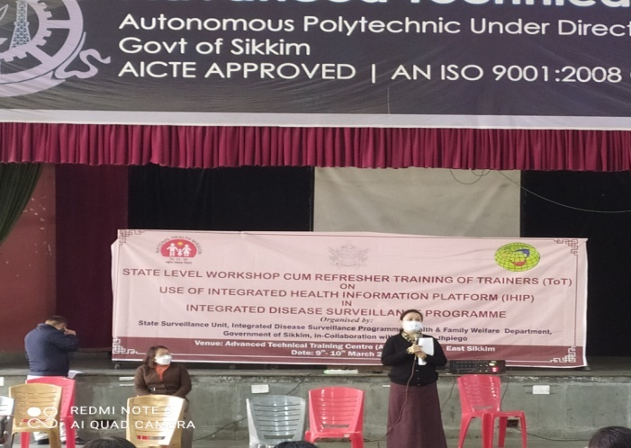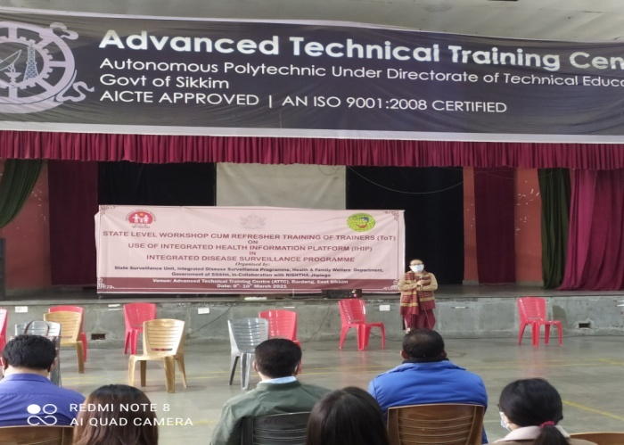
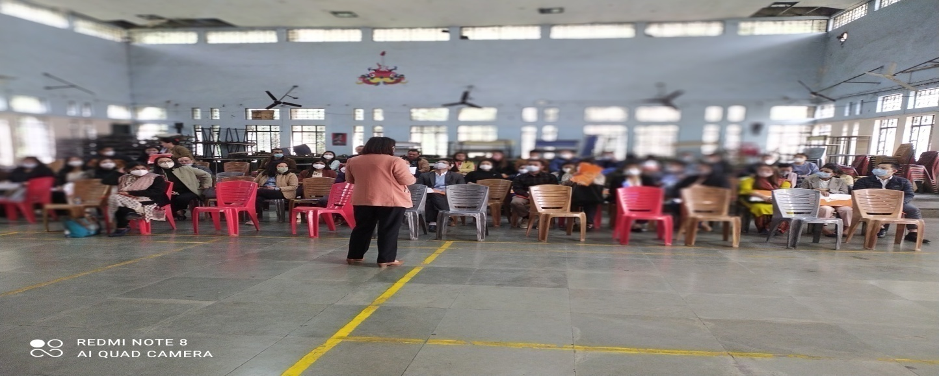

IHIP TRAINING AT SOUTH SIKKIM.
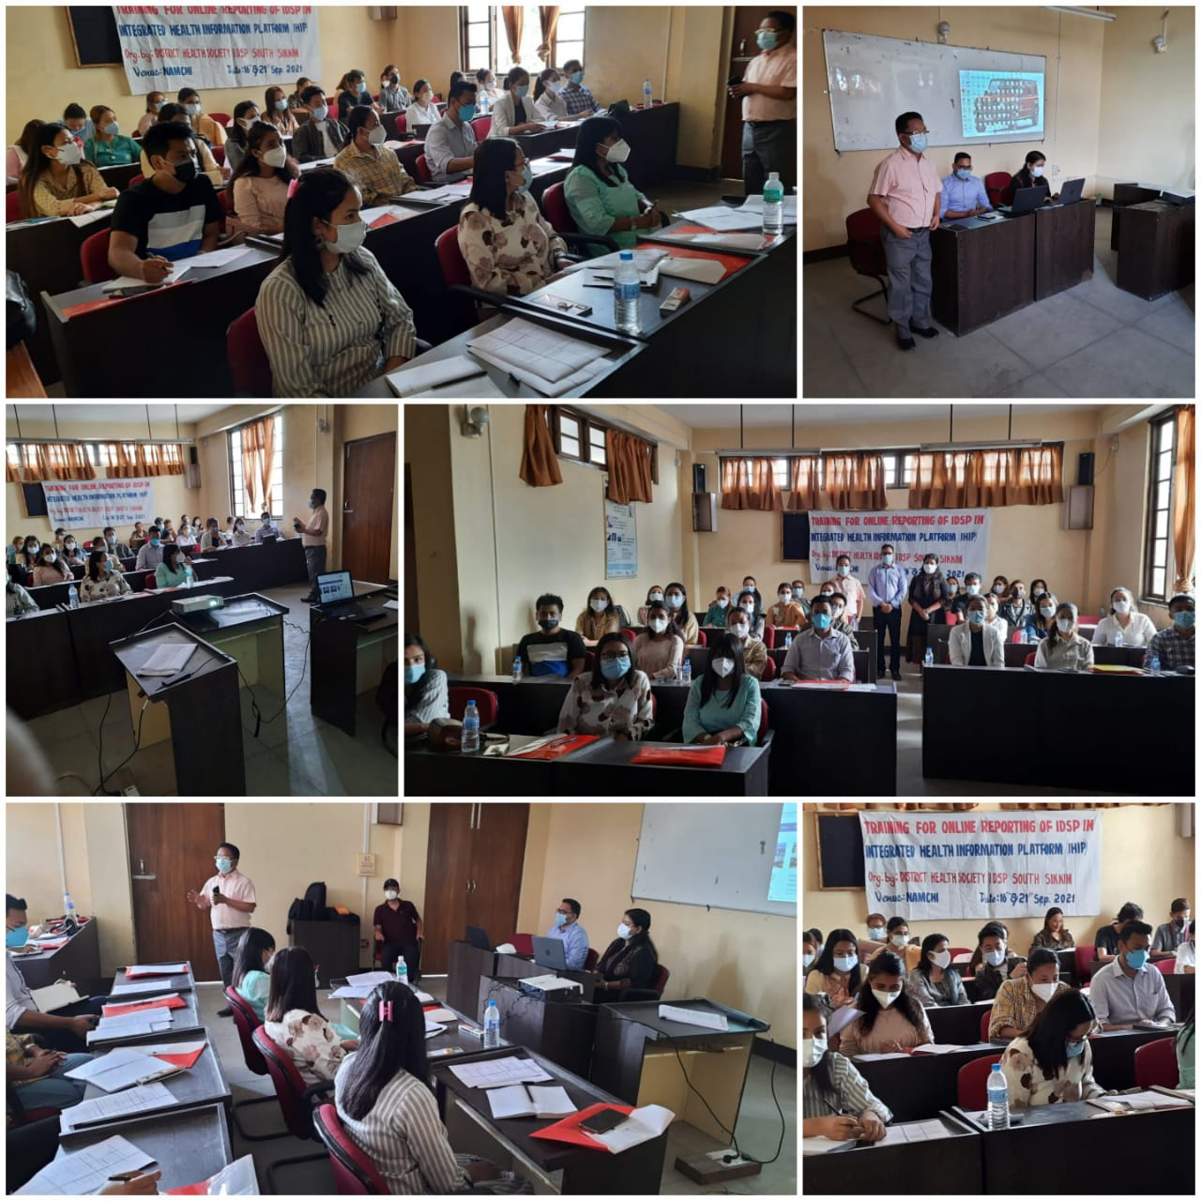

IHIP TRAINING AT DH Singtam SIKKIM.
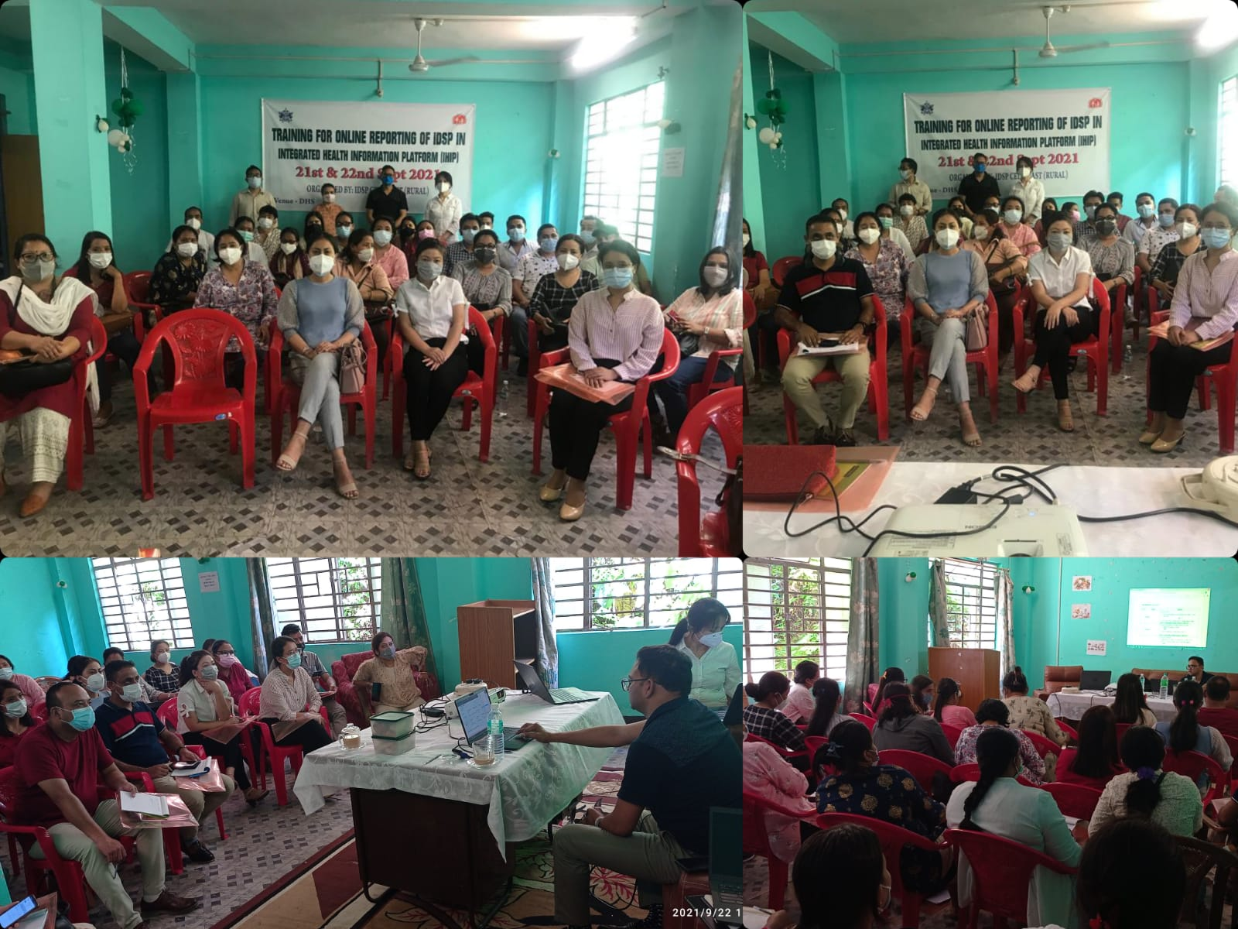
IHIP TRAINING AT DH Mangan SIKKIM.
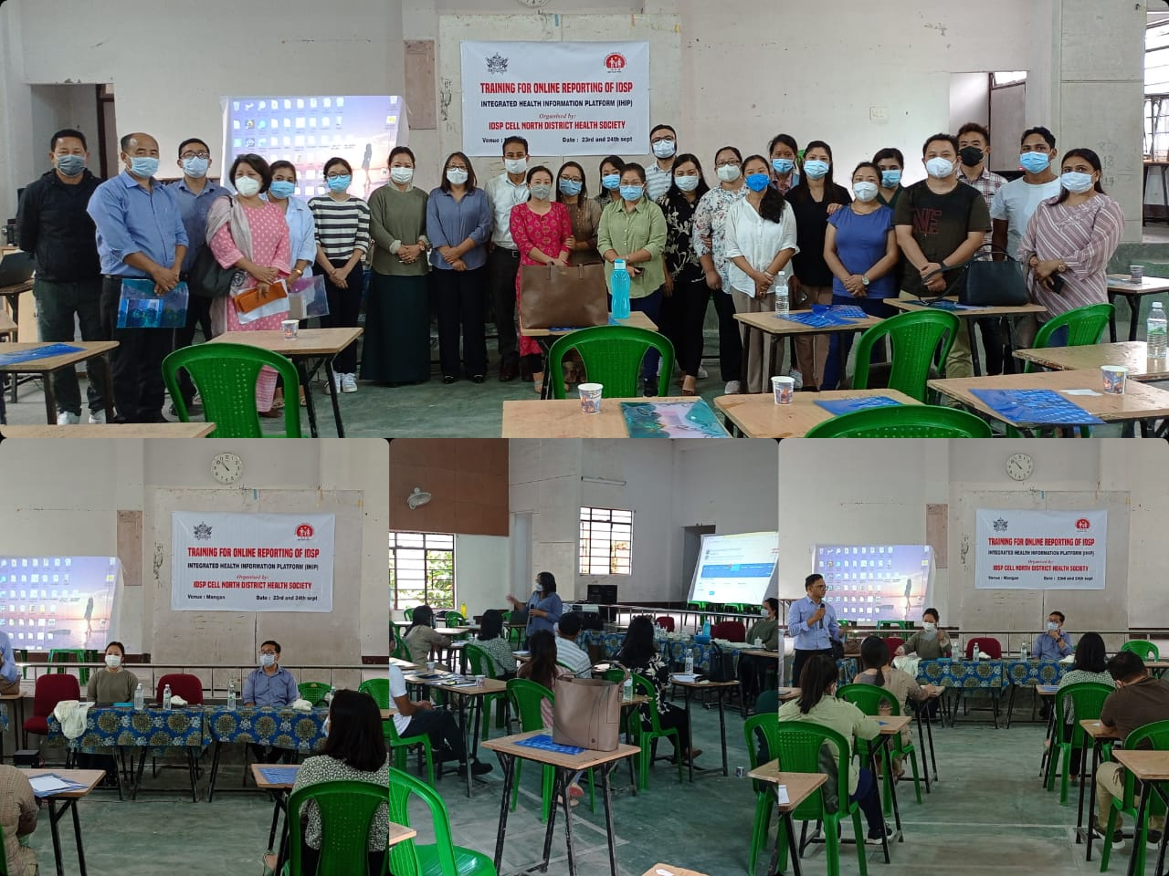
Lunching of IHIP in the State
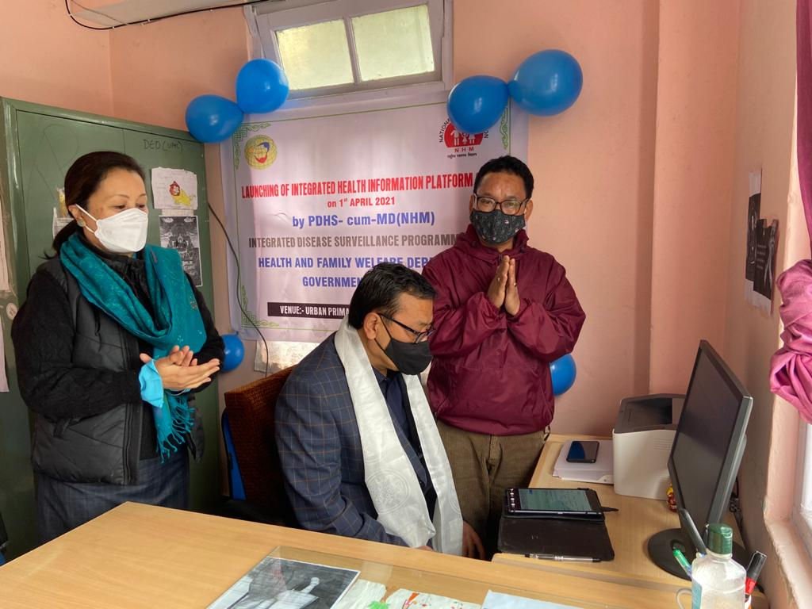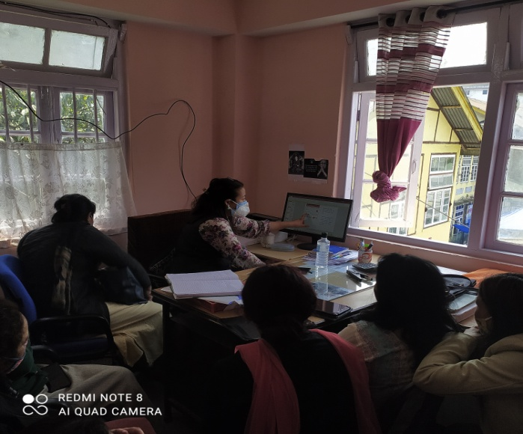

SOUTH
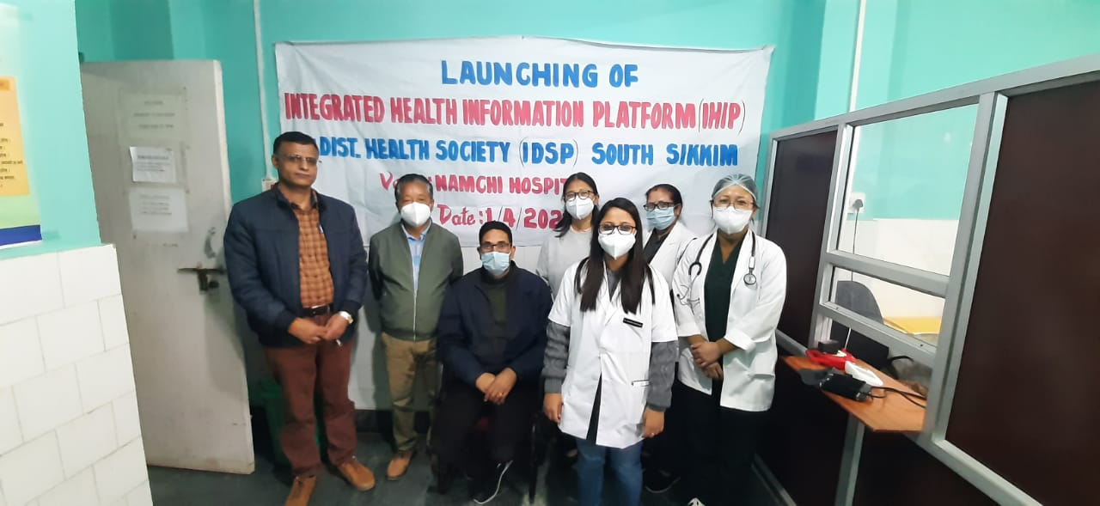
NORTH
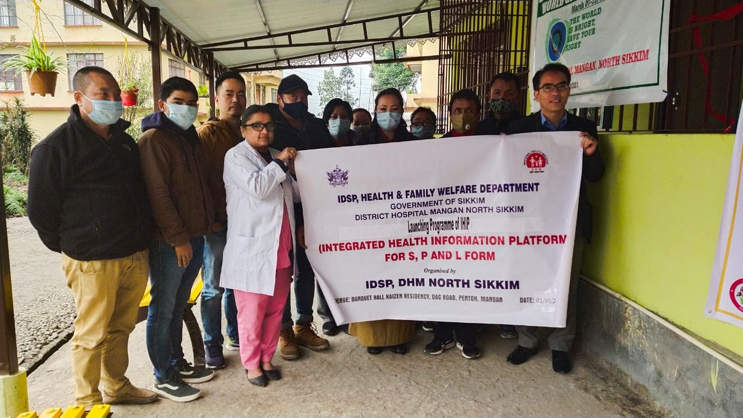
VC SESSION
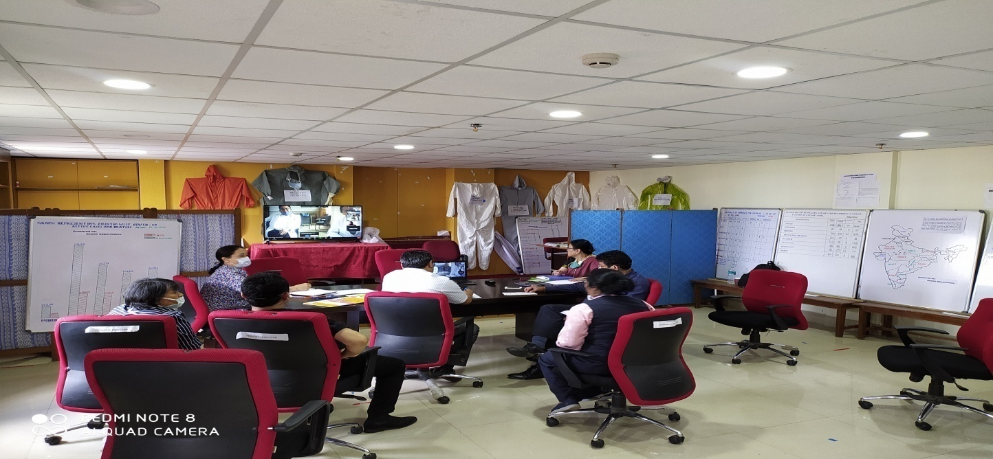
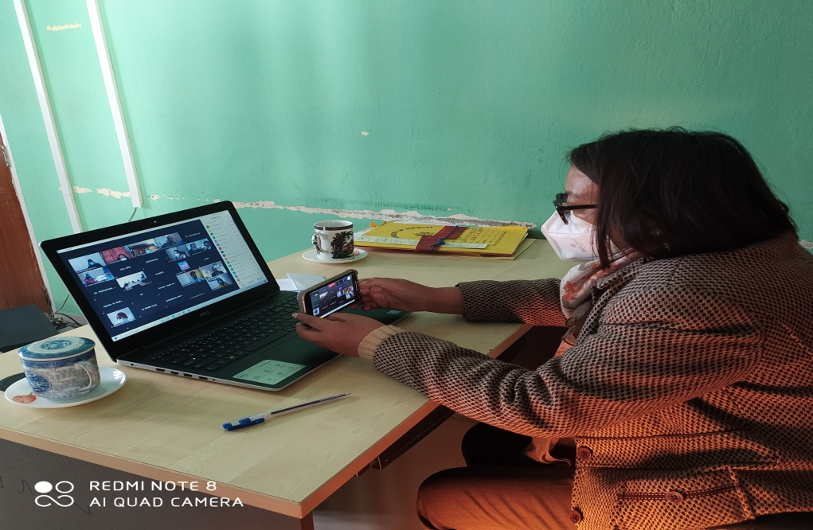
FIELD VISIT
